BCI International Research Conference BCIRC 2026

1. Cover Page
TITLE
(Capitalized/bold/centered/14 font size/Times New Roman)
Single line space

Author names: Surname + Initials
Ex 1: Perera A. B.¹ and Fernando C.D^{2,*}
Ex 2: Perera A. B.¹ and Fernando C. D.² and Perera W.E^{3,*}
(Font size – 12/centered)
Single line space

¹Affiliations
²Affiliations
(Italic/font size-10)
Single line space

E-mail of the Corresponding Author:
(Font size – 10/centered)

- Affiliations: Put numbers accordingly
- Presenting Author: Underlined
- Corresponding Author: put* after the affiliation number.
2. Abstract Page
Title
(Capitalized/bold/centered/14 font size/Times new Roman)
Abstract (Font size-12/ Bold/ Times New Roman)
All papers must include an abstract which is a brief summary of the study, limited to 250 to 300 words including title. It should concisely describe the principal findings of the work. It should be organized under the sections: problem addressed, objectives, concise methodology and approach, results and conclusions but the section headings should not be included. References should not be included in the abstract.
(Font size-12/ Times New Roman/ Spacing-1.15)
Keywords: Maximum five key words separated with commas arranged in the order of importance (Font size-10)
3. Introduction
This section should
(1) Present the scope and objective of the paper and state the problem,
(2) Briefly review the relevant literature,
(3) Discuss the scope and limitations.

4. Methodology
This section should clearly outline the research methods employed in the study. Authors must briefly describe the research design, data collection techniques and analytical methods used. The rationale for selecting these methods should also be included, demonstrating their suitability for addressing the research problem. Emphasis should be placed on how the chosen methodology supports the study’s objectives and contributes to both theoretical and practical understanding.

5. Results and Discussions
The findings/ results of the work should be explicitly described and illustrated. Supporting figures, tables and images of the results. If the study has not resulted in significant results, then the author(s) should provide a brief overview of expected results along the lines of the hypothesis setting.

6. Conclusions
Conclusions should include;
(1) The principles and generalizations inferred from the results,
(2) Any exceptions to, or problems with these principles and generalizations,
(3) Conclusions drawn, recommendations and direction for future research.

7. References
References should be listed alphabetically and presented in a format according to APA7 (American Psychological Association – 7th edition) referencing style. Examples of reference formats are given here. For additional information on formatting references, refer the Publication Manual of the American Psychological Association.

In-text citations
• One Author => (Jones, 2021).
• Two Authors => (Piaf & Montgomery, 2020)
• Three or more Authors => (McKenzie et al., 2019)

References
Book Style – Author(s) of book – family name and initials. (Year). Title of book – in italics.
Publisher. DOI or Web address - if available

Chen, W. K. (1993). Linear Networks and Systems, Belmont.

Cichocki, A. & Unbehaven, R., (1993). Neural networks for optimization and signalprocessing,
Wiley. https://doi.org/10.1016/C2017-0-00372-5

Journal Paper – Author(s) of journal article – family name and initials, use & for multiple authors. (Year). Title of journal article. Journal name – in italics, Volume – in italics (Issue or
number), Page number(s). DOI or Web address - if available

Journal Paper without DOI:

Chen, S., Mulgrew, B. & Granta, P. M. (1993). A cluster technique for digital communications
channel equalisation using radial basis function networks, IEEE Trans. on Neural Networks, 4(1), 570-578.

Journal Paper with DOI:

Hill, R. M. (1997). A single-vendor single-buyer integrated production-inventory model with
a generalized policy, European Journal of Operational Research, 97(1), 493-499. https://doi.org/10.1016/S0377-2217(96)00267-6

Online Sources Style - Author(s) of page – person or organisation, use & for multiple authors. (Year, Month Day - if available). Title of page – In italics. Website name. Web address

Vidmar, R. J. (2021, January 15). On the use of atmospheric plasmas as electromagnetic
reflectors. http://www.halcyon.com/pub/journals/21ps03-vidmar

Conference Paper – Author(s) of paper – last name and initials, use & for multiple authors. (Year, Month Date(s)). Title of paper – In italics. [Type of paper eg. Paper presentation]. Conference Name, Location. DOI or Web address - if available.

Beck, K. & Ralph, J. (1994, April 20-22). Patterns generate architectures [Paper presentation].
13th Research Libraries Conference, Bologna, Italy.

8. Figures and Tables
Figures include charts, graphs and drawings. All figures and other graphics should be embedded, or electronically placed, within the text immediately after the first point of reference, below the visuals. DO NOT place them on separate pages at the end of your extended abstract. Use Times New Roman, 10pt bold font for captions and text inside.

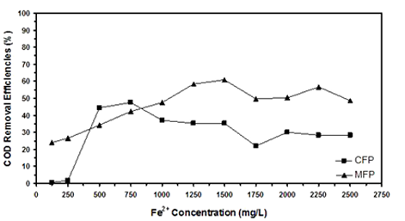

Figure 1: Figure Header (Font Size 10pt)
Source: Author, year (Font size 10)

Place the table following the same procedure, with the title positioned above.

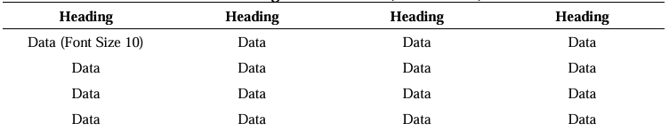
Table 1: Regression Results (Font Size 10pt)

